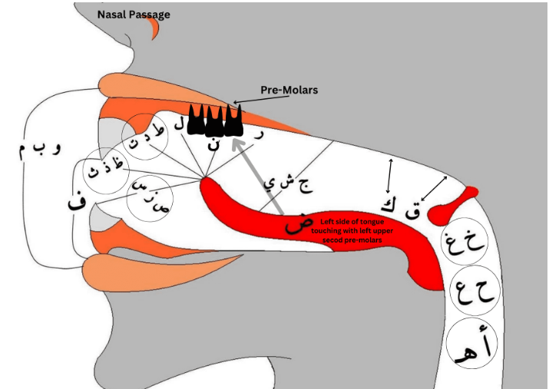

ASSIGNMENT # 1
RULES OF TAJWEED

ES-206 SE-24009 SECTION-A SOFTWARE ENGINEERING
Introduction

What is Tajweed?
The word Tajweed linguistically means ‘proficiency’ or ‘doing something well’. When applied to the Qur’an, it means giving every letter of the Qur’an its rights and dues of characteristics when we recite the Qur’an and observing the rules that apply to those letters in different situations. We give the letters their rights by observing the essential characteristics of each letter that never leave it. And we give them their dues by observing the characteristics of each letter that are present in them some of the time and not present at other times.
The Qur’an was revealed with Tajweed rules applied to it. In other words, when the angel Jibreel ((AS)) recited the words of Allah to the Prophet Muhammad (SAW) he recited them in a certain way and he showed the Prophet (SAW) the ways in which it was permissible to recite the Qur’an. So it is upon us to observe those rules so that we recite it in the way it was revealed.
History of Tajweed
At the time of the Prophet (SAW) there was no need for people to study Tajweed because they talked with what is now known as Tajweed so it was natural for them. When the Arabs started mixing with the non-Arabs as Islam spread, mistakes in Qur’an recitation started appearing, so the scholars had to record the rules. Now, because the everyday Arabic that Arabs speak has changed so much from the Classical Arabic with which the Qur’an was revealed, even Arabs have to study Tajweed.
The purpose of Tajweed
The Qur’an is the word of Allah, and its every syllable is from Allah. Its recitation must be taken very seriously. The purpose of the Science of Tajweed in essence is to make the reciter proficient in reciting the Qur’an, observing the correct pronunciation of every letter with the rulings and characteristics which apply to each letter, without any exaggeration or deficiency. And so through this the reciter can recite the Qur’an upon the way of the Prophet pbuh. as he received it from Jibreel who received it from Allah (SWT) in the Classical Arabic dialect that it came down in.
Arabic letters each have a Makhraj – an exit or articulation point - in the mouth or throat from which they originate and they also each have Sifaat – attributes, or characteristics - particular to them. Knowing the Makhraj and Sifaat of each letter is an important part of Tajweed. Sometimes two letters have very similar exits which makes mixing them up easy. So if a person does not know the attributes of each letter there is a danger that he will change the meaning of the words in Qur’an recitation. Observing the rules of Tajweed in reciting protects the reciter from making mistakes in reciting the Qur’an.
The obligation of Tajweed
The proofs that the scholars bring to show the obligation of Tajweed is that Allah says in the Qur’an,
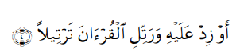
The meaning of which is: ‘And recite the Qur’an (aloud) in a (slow and melodious) style (tarteela)’ (Surah Muzzammil, Ayah 4)
Ali ibn Abi Talib (RA) said in the explanation of this aayah: “at-Tarteel is Tajweed of the letters and knowing where to stop (correctly)”. [An-Nashr of Ibn Al-Jazaree 209:1]
There are various Ahadeeth also showing us the importance of Tajweed. Umm Salamah was asked about the recitation of the Prophet (SAW) and she described it as a recitation ‘clearly-distinguished letter by letter’. [Tirmidhi]
Ibn al-Jazari (may Allah have mercy on him) said: Whoever is able to read the words of Allah with correct Arabic pronunciation but he deliberately pronounces it incorrectly like a non-Arab, out of arrogance, stubbornness and complacency, or because he is too proud to go to a scholar who could help him to correct his pronunciation, is undoubtedly falling short and sinning and being dishonest. The Messenger of Allah (SAWW) said: “Religion is sincerity: to Allah, to His Book, to His Messenger, and to the leaders of the Muslims and their common folk.”
Mistakes in Tajweed
The scholars have divided the types of mistakes one might fall into when reciting the Qur’an into two types:
1.Clear mistakes and
2.Unobvious (hidden) mistakes.
The Clear mistakes must be avoided by all and to avoid them one must know the rules of Tajweed. If a person falls into the Clear Mistakes, this is considered a sin. As for the Unobvious mistakes, then the ruling on them is lighter and the recitation of a person falling into this type of mistake is regarded as lacking in completeness and prayer behind such a person is sound.
Helpful Tips towards learning Tajweed
* You must find a Qur’an teacher who has studied Tajweed to listen to your recitation and correct you. Tajweed cannot merely be learnt from books, because the movements of your mouth as well as the sounds are important and only a teacher can correct you and make sure you are applying the rules correctly.
* Listen to Qur’an tapes of reciters who recite very clearly, at a medium or slow speed and notice them applying the different rules of Tajweed. Repeat after them while trying to apply the rules you’ve learnt. Try to copy their tone.
* Apply the rules you learn to the Surahs you have already memorized and don’t save any effort about reciting correctly. You might have to revise the surahs by looking back at them.

Benefits of learning Tajweed
The benefits of learning Tajweed are many as reflected in some of the following Ahadeeth:
- The reciters of the Qur’an will be in the company of the noble and obedient angels ‘Aa’ishah, may Allah be pleased with her, relates that the Prophet (SAW) said: “Verily the one who recites the Qur’an beautifully, smoothly, and precisely, he will be in the company of the noble and obedient angels. And as for the one who recites with difficulty, stammering or stumbling through its verses, then he will have TWICE that reward.” [Al-Bukhari and Muslim]
- You will be from the best of people ‘Uthmaan, may Allah be pleased with him, said that the Prophet (SAW) said: “The best of you are the ones who learn the Qur’an and teach it to others” [Al-Bukhari]
- The Qur’an will lead you to Paradise! The Qur’an is an intercessor, something given permission to intercede, and it is rightfully believed in. Whoever puts it in front of him, it will lead him to Paradise; whoever puts it behind him, it will steer him to the Hellfire.” [An authentic hadith found in AtTabaraanee, on the authority of ‘Abdullaah ibn Mas’ood]

Rules of Noon and Meem Mushaddad

The way of pronouncing:
If a Meem or Noon is Mushaddad (that is, it has a shaddah sign on it), the reader must do Ghunnah (or Nasal sound) of 2 (beats) on it.
Examples:

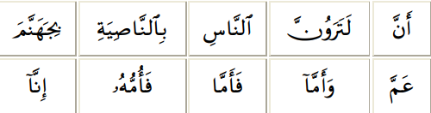

Al –Qalqalah

The meaning of Qalqalah:
Means vibration, it is the vibration of sound at the end of the pronunciation of a letter. It can be stated as a state between a Saakin (letter with Sukoon sign on it) and Mutaharrik (letter with Movement)
Letters of Qalqalah:
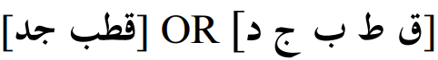
They are collected in the words

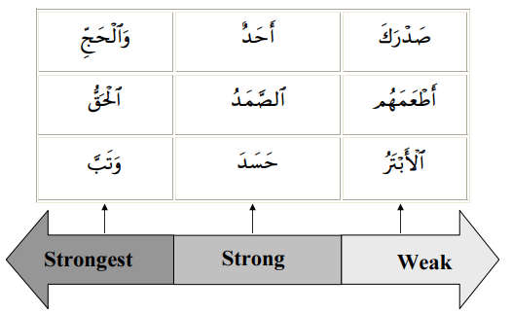
Examples:

The Heavy and light Letters

1. Heavy letters
They are collected in the phrase

The heavy letters have the quality of Isti’laa 2 “rising high”. Because while pronouncing them, a part of the tongue (mostly the back part) rises up to the roof makes the letter sound heavy.
2. Light letters
All the letters other than the heavy letters and the temporary heavy and light letters.
The Light Letters have the quality of Istifaal “falling down”, by lowering the tongue when pronouncing the light letter.
3. Alif Madd
The quality of Alif Madd being heavy or light depends on the letter preceding Alif Madd. If the letter before Alif Madd was light, so Alif Madd should accordingly take a light sound. And if the letter before Alif Madd was heavy, so Alif Madd should accordingly take a heavy sound.

The Rules of Noon Sakin and Tanween

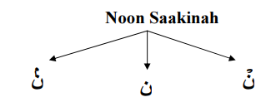
Noon Saakinah: is a Noon with no Harakah or with a Sukoon sign on it.

Tanween: Is actually a noon Saakinah which comes at the end of the nouns. It is pronounced but not written as Noon Saakinah.

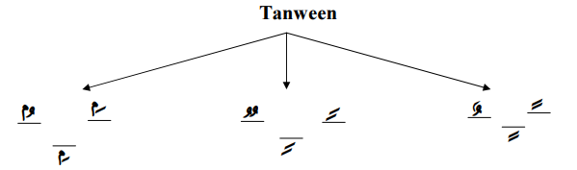
Rules of Noon Saakinah and Tanween
• Izhar Halqi
• Idgham
• Iqlaab
• Ikhfaa’ Haqiqi

First: Izhaar Halqi
• Izhaar means “clear”
• Izhaar Letters: the throat letters
• The way of pronunciation :
If a Noon Saakin or a Tanween is followed by any of the six throat letters, The Noon Saakin or the Tanween is pronounced clearly from its respective origination without Ghunnah.
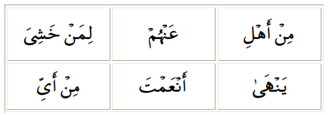
• Examples on Noon Saakin

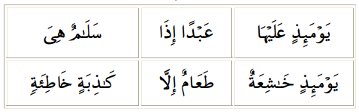
• Examples on Tanween
Second: Iqlaab
• Iqlaab means: “to turn over” • Iqlaab letters:- “”
• The way of pronunciation:
If a Noon Saakin or Tanween is followed by “ب“, it is converted into a hidden Meen with separating between lips. And the reader should make Ghunnah for 2 beats
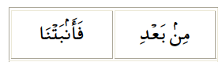
• Examples on Noon Saakin

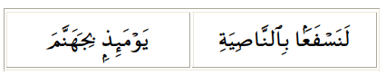
• Examples on Tanween

Third: Idghaam
• Idghaam means: “To mix” or to “put one thing into another”. It is the mixing or entering of a Saakin letter into a Mutaharrik letter following it, so that they became a single Mushaddad letter.
• Idghaam Letters:
There are six letters of Idghaam which are collected in the word
• The way of pronunciation: Skip the Noon or Tanween and Pronounce Ghunna with the following letter for 2 beats.
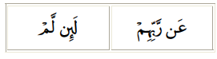
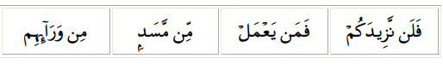
- Examples on Noon Saakin
- Examples on Tanween
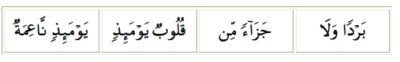
Fourth: Ikhfaa Haqiqi
• Ikhfaa maens: “To hide”, It is the pronunciation Of Noon Saakina or Tanween In a way so that the sound is between Idghaam and Izhaar.
• Letters of Ikhfaa:-
Any letter other than the lettes of Izhaar, Iqlaab or Idghaam letters.
• The way of pronunciation:
If any letter other than the letters of Izhaar, Iqlaab or Idghaam letters follows the Noon Saakin or Tanween, the Reader should hide the Noon Saakin or Tanween. The reader is also required to make Ghunnah for two beats.
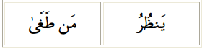
- Examples on Noon Saakin
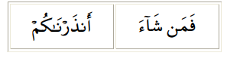
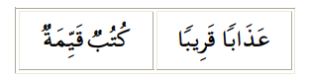
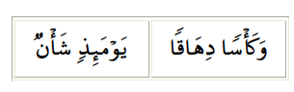
- Examples on Tanween

Al-Madd
• Al-Madd means: Long.
Conventionally, it may be defined as to make the Madd letters long under some conditions.
• The way of pronunciation
Al-Madd can be prolonged from two to six beats depending upon its kind.
• Types of Madd:
• Madd Tabee’ee
• Madd Al-Bada
• Madd Ewadh
• Madd Aaridh Li-Ssukoon
• Madd Al-Leen
• Madd Waajib Muttasil
• Madd Jaa’ez Munfasil
• Madd Laazim

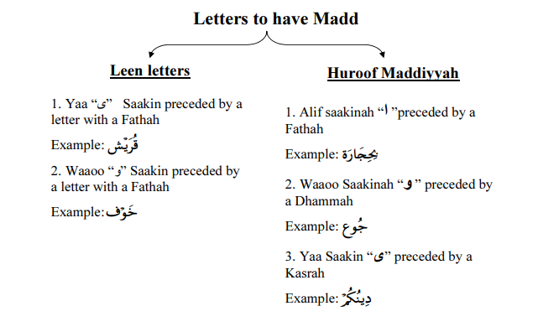

The Qualities of the letters
First: The Permanent Qualities With Opposites
Types & Definitions
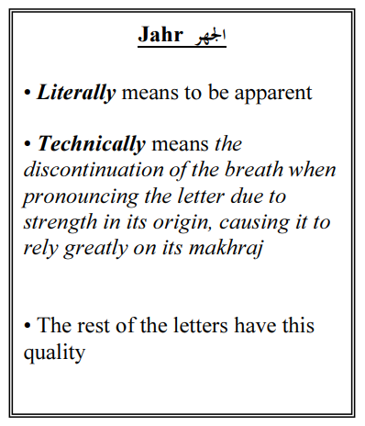
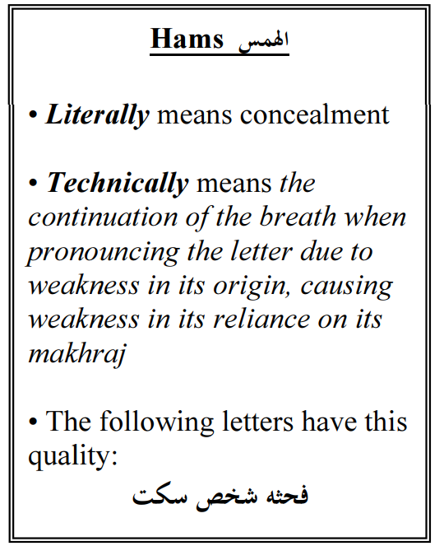

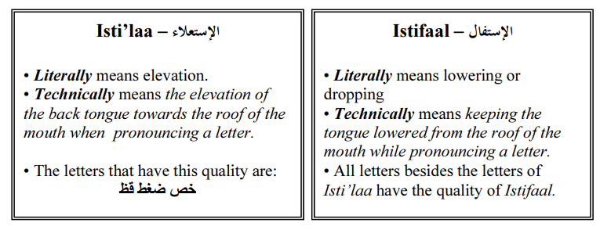

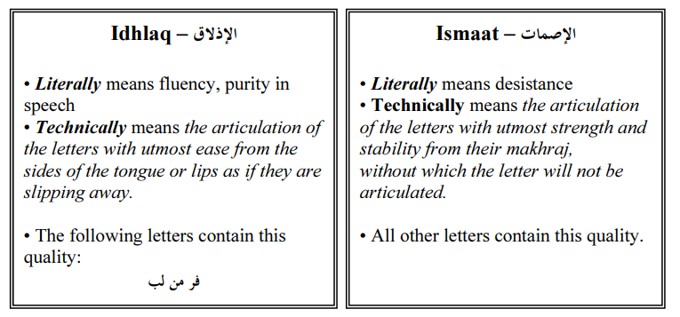

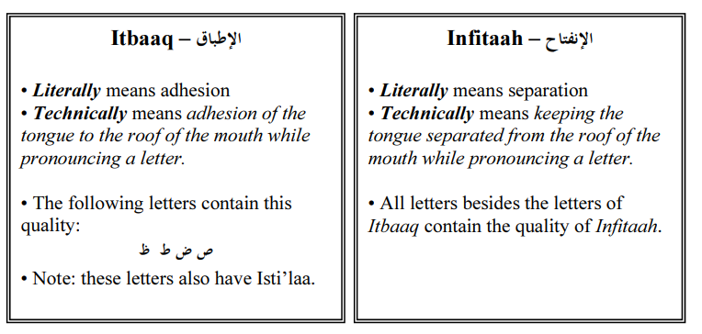

Second: The Permanent Qualities Without Opposites
Types & Definitions
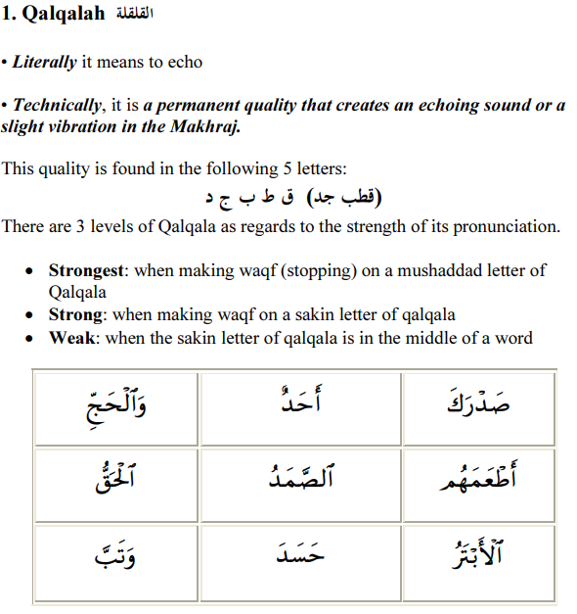

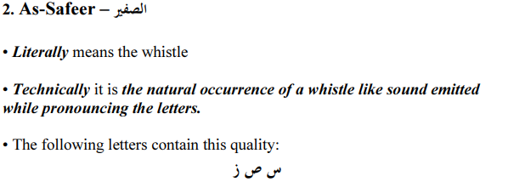

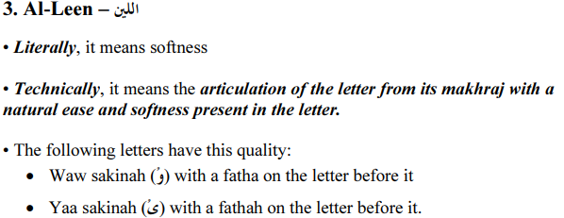

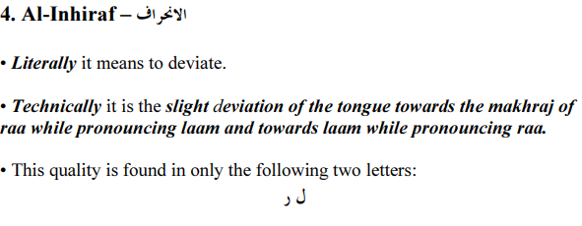

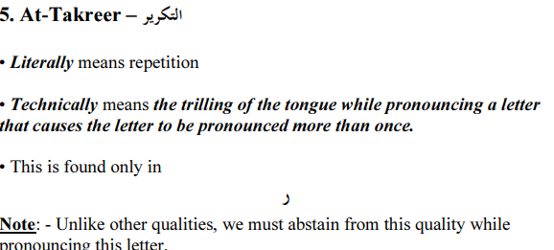

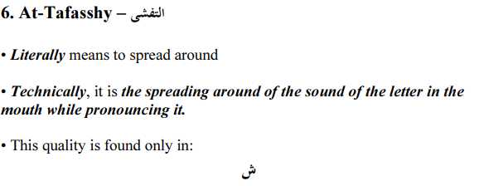

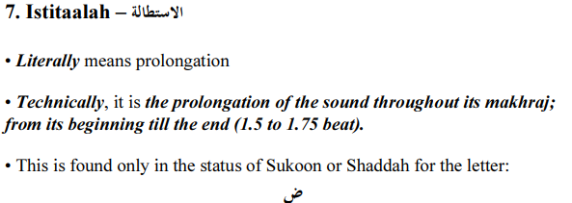

Conclusion
The study of Tajweed is not merely a linguistic exercise but a sacred discipline that preserves the divine authenticity of the Qur’an. By adhering to its rules, Muslims ensure that every letter is pronounced with its correct Makhraj (articulation point) and Sifaat (attributes), safeguarding the Qur’an from distortion and maintaining the purity of its recitation as revealed to the Prophet Muhammad (ﷺ).

Key Takeaways from Tajweed Rules
- Precision in Pronunciation
  - Tajweed governs the exact articulation of Arabic letters, distinguishing between similar sounds (e.g., ط vs. ت, ص vs. س).
  - Rules like Ikhfaa (hiding) and Idghaam (merging) refine recitation fluency.
- Avoiding Major & Minor Mistakes
  - Clear mistakes (Lahn Jali) change meanings (e.g., قلب "heart" vs. كلب "dog") and are religiously prohibited.
  - Hidden mistakes (Lahn Khafi) affect perfection but are excusable for beginners.
- Spiritual and Linguistic Benefits
  - Proper Tajweed fulfills Allah’s command:
"And recite the Qur’an with measured recitation." (Qur’an 73:4)
  - The Prophet (ﷺ) emphasized:
"The one who is proficient in the Qur’an will be with the noble angels." (Bukhari 4937)

- Structural Rules Mastery
  - Noon Sakinah & Tanween: Izhaar, Idghaam, Iqlaab, and Ikhfaa ensure clarity in nasal sounds.
  - Madd (Prolongation): Ranges from 2–6 beats (e.g., Madd Tabee’ee for natural elongation).
  - Qalqalah: Echo effect on ق, ط, ب, ج, د at word endings (e.g., قُلْ → "Qulْ").

Practical Steps for Mastery
- Seek a Qualified Teacher: Tajweed requires oral correction; books alone are insufficient.
- Listen & Imitate: Recite alongside Qaris like Sheikh Al-Hussary or Sheikh Sudais.
- Daily Practice: Apply rules to memorized Surahs (e.g., Al-Fatihah, Al-Ikhlas).

Final Reflection
Tajweed bridges the gap between human recitation and divine revelation. By perfecting it, Muslims honor the Qur’an’s sanctity, follow the Sunnah, and unlock spiritual rewards. As Ibn Al-Jazari stated:
"The Qur’an is Allah’s rope; whoever holds tight to it will be guided."
May this knowledge inspire diligent practice and a lifelong connection with the Qur’an’s miraculous beauty.

